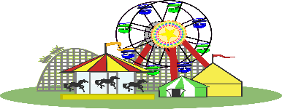 McLean County Fair
Food - Craft - Vendor Show
June 18th – 19th – 20th, 2021
Located at the Fairgrounds in Underwood, ND

“Indoors” Space charge $15.00 per booth per day. “Outdoors” Space charge $10.00 per booth per day.
Indoor booth space approximately 9’ x 9’, with back and side curtains – tables/chairs are not provided.
Times vary due to scheduled events during the Fair. Vendors selling similar items will be chosen
on a “first come” basis. A Fair Gate Admission fee of $5.00 per person/per day is payable at the gate.

Mail Entry Forms and Registration Fee to: McLean County Fair
PO Box 103
Underwood, ND 58576

Inside Booths Open:
Friday, June 18th 2:00pm – 9:00pm $15 or $10 x _________ Booths = $_____________________
Saturday, June 19th 12:00pm – 9:00pm $15 or $10 x _________ Booths = $_____________________
Sunday, June 20th 12:00pm – 5:30pm $15 or $10 x _________Booths = $_____________________
Total Booths _________ Amount Enclosed $______________
ND Tax Permit No. _________________________________________________________________________
*Food Vendor Health License No. ______________________________________________________________
(*First District Health Unit code requires all food handlers to have a Food Safety card.)

Legal Name _______________________________________________________________________________
Doing Business As __________________________________________________________________________
Mailing Address____________________________ City/Zip Code ____________________________________
Phone or Cell Phone________________________________________________________________________
Products Selling ___________________________________________________________________________
_________________________________________________________________________________________
_________________________________________________________________________________________
Electricity needed? _________________________ Camping space needed?___________________________

For more information contact Diane Schell – 701-220-3841 (c) 701-442-5481 (w)

